Report 2.2

1. Display the image intensity histogram of P using 10 bins by >> imhist(P,10);

Next display a histogram with 256 bins. What are the differences?

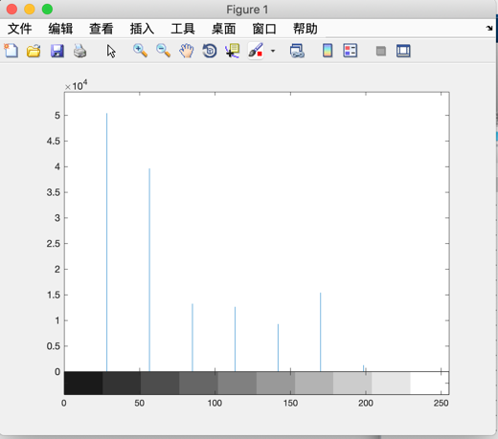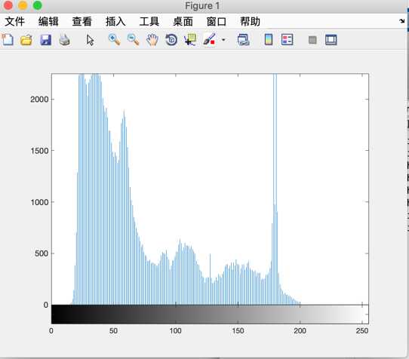

1. Next, carry out histogram equalization as follows:

>> P3 = histeq(P,255);

Redisplay the histograms for P3 with 10 and 256 bins. Are the histograms equalized? What are the similarities and differences between the latter two histograms?

No,相似之处是他们都拥有差不多的波动趋势，不同之处是256bin的拥有更多的“细节“

1. Rerun the histogram equalization on P3. Does the histogram become more uniform? Give suggestions as to why this occurs.

没有变得更统一，因为这个histeq函数的关系，这个函数的使用方法是：

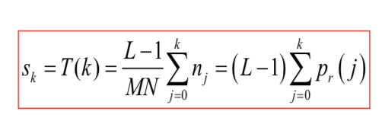重复应用并不会提升他的水平